USR_TBL | RENTAL_TBL
UserID PK | RentalID PK
Username | UserID FK
Password | MovieID
Email | Quantity
Address | Approval
City
Phone

USR_TBL DATA
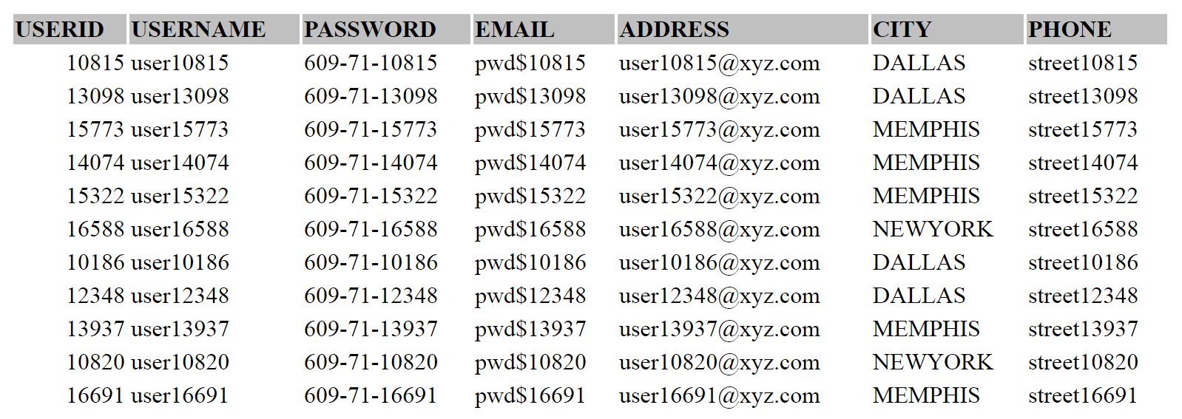
RENTAL_TBL_DATA
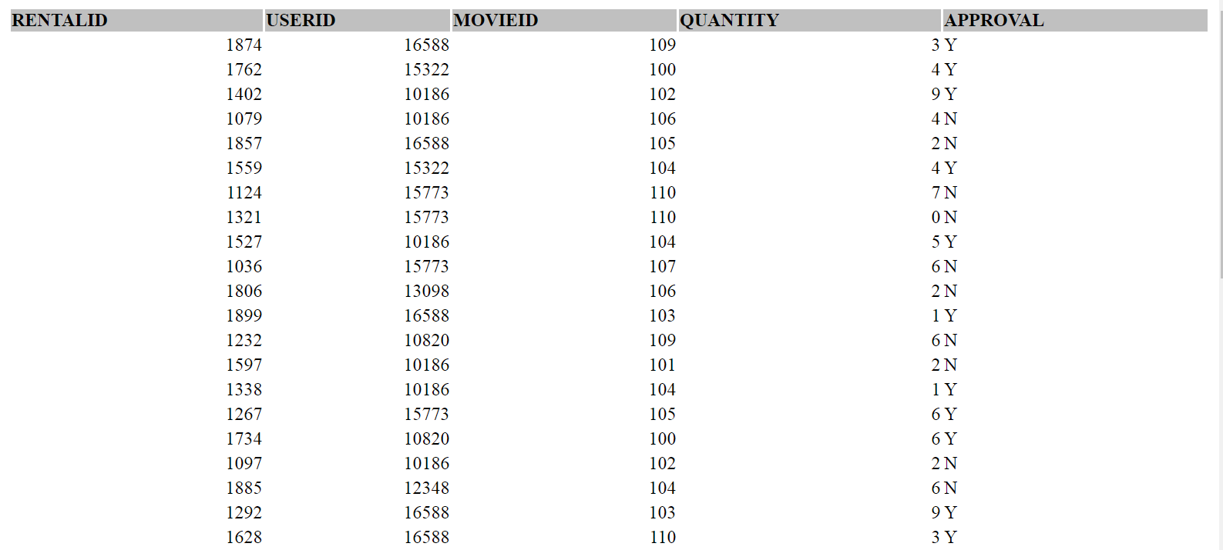

1. Using the table structure you defined, write a SQL query that retrieves all users that have rented more than one movie. Provide the UserID for each record and do not retrieve duplicate UserIDs
The below SQL Query retrieves unique User IDs of all users who rented more than one movie. Also the column Approval = 'Y' means the rental is successful, otherwise 'N' for rental failure.
SELECT DISTINCT USERID, COUNT (DISTINCT MOVIEID) AS MOVIESRENTED
FROM RENTAL_TBL
WHERE APPROVAL = 'Y'
GROUP BY USERID
HAVING COUNT (DISTINCT MOVIEID) > 1
ORDER BY MOVIESRENTED DESC;

2. Using the table structure you defined, write a SQL query that returns the top 3 users that rented that most movies. Provide the complete user record for each username.
The below SQL Query retrieves the top three user data who rented most movies
SELECT USR.*
FROM USR_TBL USR,
(SELECT DISTINCT USERID, COUNT (DISTINCT MOVIEID) AS MOVIESRENTED
FROM RENTAL_TBL
WHERE APPROVAL = 'Y'
GROUP BY USERID
ORDER BY MOVIESRENTED DESC) RENTALSTATS
WHERE USR.USERID = RENTALSTATS.USERID AND ROWNUM <= 3;

